**Shubhan Singh**

**2022300118**

**SE-Comps B/Batch C**

**21st March 2024**

**Scilab no.6: Gauss Seidel Method**

**Program No.1** :- Write a Scilab code to solve the equations in terms of x,y,z by using gauss seidel method performing 5 iterations.

27x+6y-z=85

6x+15y+2z=72

x+y+z+54z=110

**Code :-**

clc;

clear all

A=[27 6 -1;6 15 2;1 1 54]

B=[85;72;110];

n=5;

x=0;

y=0;

z=0;

for i=1:n

printf("\nIteration number %g",i)

x=(B(1)-A(1,2)*y-A(1,3)*z)/A(1,1)

y=(B(2)-A(2,1)*x-A(2,3)*z)/A(2,2)

z=(B(3)-A(3,1)*x-A(3,2)*y)/A(3,3)

printf("\nValue of x : %g",x)

printf("\nValue of y : %g",y)

printf("\nValue of z : %g",z)

end

**Output :-**

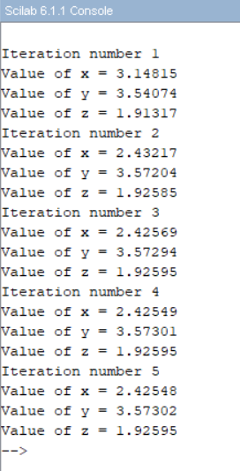

**Program No. 2:-** Write a Scilab code to solve the equations in terms of x,y,z by using gauss seidel method performing 7 iterations.

28x+4y-z=32

2x+17y+4z=35

x+3y+10z=24

**Code**:-

clc;

clear all

A=[28 4 -1; 2 17 4; 1 3 10]

B=[32; 35; 24];

n=7;

x=0;

y=0;

z=0;

for i=1:n

printf("\nIteration number %g",i)

x=(B(1)-A(1,2)*y-A(1,3)*z)/A(1,1)

y=(B(2)-A(2,1)*x-A(2,3)*z)/A(2,2)

z=(B(3)-A(3,1)*x-A(3,2)*y)/A(3,3)

printf("\nValue of x : %g",x)

printf("\nValue of y : %g",y)

printf("\nValue of z : %g",z)

end

**Output** :-

**Program No. 3 :-** Write a Scilab code to solve the equations in terms of x,y,z,w by using gauss seidel method performing 10 iterations

20x+2y+3z+6w=42

2x+15y+4z+4w=48

2x+7y+15z+4w=110

3x+3y+z+9w=69

**Code** :-

clc

A = [20 2 3 6; 2 15 4 4; 2 7 15 4; 3 3 1 9];

B = [42;48;110;69];

x = 0;

y = 0;

z = 0;

w = 0;

n=10;

for i = 1: n

printf("\nIteration :%g",i)

x = (B(1) - A(1,2)*y - A(1,3)*z-A(1,4)*w)/A(1,1)

y = (B(2) - A(2,1)*x-A(2,3)*z-A(2,4)*w)/A(2,2)

z = (B(3) - A(3,1)*x - A(3,2)*y-A(3,4)*w)/A(3,3)

w = (B(4) - A(4,1)*x - A(4,2)*y - A(4,3)*z)/A(4,4)

printf("\nThe value of x is :%g",x)

printf("\nThe value of y is :%g",y)

printf("\nThe value of z is :%g",z)

printf("\nThe value of w is :%g",w)

end

**Output** :-

**Program no. 4** :- Write a Scilab code to solve the equations in terms of x,y,z,w by using gauss seidel method performing 11 iterations

225x+120y+z=698

127x+150y+3z=630

240x+y+80z=434

**Code** :-

clc;

clear all

A=[225 120 1; 127 150 3; 240 1 80]

B=[698; 630; 434];

n=11;

x=0;

y=0;

z=0;

for i=1:n

printf("\nIteration number %g",i)

x=(B(1)-A(1,2)*y-A(1,3)*z)/A(1,1)

y=(B(2)-A(2,1)*x-A(2,3)*z)/A(2,2)

z=(B(3)-A(3,1)*x-A(3,2)*y)/A(3,3)

printf("\nValue of x : %g",x)

printf("\nValue of y : %g",y)

printf("\nValue of z : %g",z)

end

**Output** :-

**Program No. 5** :- Write a Scilab code to solve the equations in terms of x,y,z by using gauss seidel method performing 7 iterations

4x-2y-z= 40

x-6y+2z= -28

x-2y+12z= -86

**Code** :-

clc

clear all

A = [4 -2 -2; 1 -6 2; 1 -2 12]

B = [40; -28; -86]

x = 0

y = 0

z = 0

n = 7

for i = 1:n

printf("\nIteration:%g", i)

x = (B(1) - A(1 , 2)*y - A(1 , 3)*z)/A(1,1)

y = (B(2) - A(2 , 1)*x - A(2 , 3)*z)/A(2,2)

z = (B(3)- A(3 , 1)*x - A(3 , 2)*y)/A(3,3)

printf("\nThe value of x is %g" , x);

printf("\nThe value of y is %g", y);

printf("\nThe value of z is %g" , z);

end

**Output** :-

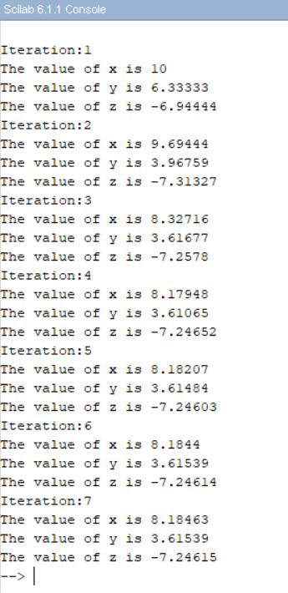

**Program No. 6** :- Write a Scilab code to solve the equations in terms of x,y,z by using gauss seidel method performing 10 iterations

25x+2y+z=69

2x+10y+z=63

x+y+z=43

**Code** :-

clc

clear all

A = [25 2 1; 2 10 1; 1 1 1]

B = [69; 63; 43]

x = 0

y = 0

z = 0

n = 10

for i = 1:n

printf("\nIteration:%g" , i);

x = (B(1) - A(1 , 2)*y - A(1 , 3)*z )/A(1 , 1);

y = (B(2) - A(2 , 1)*x - A(2 , 3)*z )/A(2 , 2);

z = (B(3) - A(3 , 1)*x - A(3 , 2)*y )/A(3 , 3);

printf("\nThe value of x is %g",x)

printf("\nThe value of y is %g",y)

printf("\nThe value of z is %g",z)

end

**Output** :-

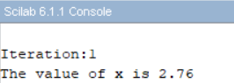

**Program No. 7** :- Write a Scilab code to solve the equations in terms of x,y,z by using gauss seidel method performing 7 iterations

15x+y+z=17

2x+15y+z=18

x+2y+55z=18

**Code** :-

clc

clear all

A = [15 1 1; 2 15 1; 1 2 55]

B = [17; 18; 18]

x = 0

y = 0

z = 0

n = 7

for i = 1:n

printf("\nIteration:%g" , i);

x = (B(1) - A(1 , 2)*y - A(1 , 3)*z )/A(1 , 1);

y = (B(2) - A(2 , 1)*x - A(2 , 3)*z )/A(2 , 2);

z = (B(3) - A(3 , 1)*x - A(3 , 2)*y )/A(3 , 3);

printf("\nThe value of x is %g",x)

printf("\nThe value of y is %g",y)

printf("\nThe value of z is %g",z)

end

**Output** :-

**Program No. 8** :- Write a Scilab code to solve the equations in terms of x,y,z,w by using gauss seidel method performing 11 iterations

16x+2y+3z+8w=46

2x+15y+4z+7w=52

9x+7y+22z+8w=63

3x+2y+z+14w=71

**Code** :-

clc;

A=[16 2 3 8;2 15 4 7;9 7 22 8;3 2 1 14];

B=[46;52;63;71];

n=11;

x=0;

y=0;

z=0;

w=0;

for i=1:n

printf("\nIteration number %g",i);

X=(B(1)-A(1,2)*y-A(1,3)*z-A(1,4)*w)/A(1,1);

Y=(B(2)-A(2,1)*x-A(2,3)*z-A(2,4)*w)/A(2,2);

Z=(B(3)-A(3,1)*x-A(3,2)*y-A(3,4)*w)/A(3,3);

W=(B(4)-A(4,1)*x-A(4,2)*y-A(4,3)*z)/A(4,4);

printf("\nValue of x=%g",X);

printf("\nValue of y=%g",Y);

printf("\nValue of z=%g",Z);

printf("\nValue of w=%g",W);

x=X;

y=Y;

z=Z;

w=W

end

**Output** :-

